**A REPORT ON**

**PROJECT BASED LEARNING-II (210258)**



SUBMITTED TO SAVITRIBAI PHULE PUNE UNIVERSITY, PUNE

IN PARTIAL FULFILLMENT OF THE REQUIREMENTS FOR THE AWARD OF THE DEGREE

**SE Computer Engineering**

BY

STUDENT NAME: PRN NO.

Kishor Gadhave  72249239G

Nilesh Jadhav  72249276G

Supriya Bankar  72249195G

Shivani Deshmukh  72249228G

**Under the guidance of**

Prof. Vikas More



**DEPARTMENT OF COMPUTER ENGINEERING DHOLE PATIL COLLEGE OF ENGINEERING WAGHOLI, PUNE-41220**

**(2023-2024)**

# CERTIFICATE

This is to certify that Kishor Gadhave, Nilesh Jadhav, Supriya Bankar, Shivani Deshmukh Branch Computer Engineering has successfully completed the work associated with **Project Based Learning II (210258**) titled as **“Healthcare Chatbot”** and have submitted the report under guidance of Prof. Vikas More, in the partial fulfillment of Second Year Bachelor of Engineering of Savitribai Phule Pune University.

Date: 18/04/2024

Place: Dhole Patil College of Engineering, Pune

|  |  |  |
| --- | --- | --- |
| Prof. Vikas More | Dr. Aarti Dandavate | Dr. Omprakash Rajankar |
| Guide Name | HOD | Principal |

# ACKNOWLEDGEMENT

This is a great pleasure & immense satisfaction to express our deepest sense of gratitude & thanks to everyone who has directly or indirectly helped us in completing our Project work successfully.

We express our gratitude towards our mentor Prof. Vikas More for his support and HOD Dr. Aarti Dandavate who guided and encouraged us in completing the project work in scheduled time.

We would like to thank our Principal Dr. Omprakash Rajankar, for allowing us to pursue the project in this institute.

S.E Computer engineering:

Student names (PRN No)

Kishor Gadhave:( 72249239G)

Nilesh Jadhav: (72249276G)

Supriya Bankar:( 72249195G)

Shivani Deshmukh:( 72249228G)

**ABSTRACT**

This report introduces a pioneering healthcare chatbot designed to revolutionize accessibility to medical services. Leveraging cutting-edge artificial intelligence (AI) technologies such as natural language processing (NLP) and machine learning.

The chatbot serves as a virtual healthcare assistant capable of understanding user inquiries, providing medical information, and offering personalized recommendations.

Emphasizing user-centric design, the chatbot ensures an intuitive interaction experience for individuals of all technical backgrounds.

By addressing barriers such as geographical limitations and resource constraints, the chatbot facilitates timely access to medical advice and assistance, complementing existing healthcare infrastructure.

This innovative approach represents a cost-effective and scalable solution to meet the increasing demand for accessible healthcare services.

By democratizing healthcare and promoting health equity, the healthcare chatbot contributes significantly to improving public health outcomes.Top of Form

**INDEX**

|  |  |  |
| --- | --- | --- |
| SR No | Particular | Page No |
| 1 | Introduction | 1 |
| 2 | Problem Statement | 2 |
| 3 | Motivation | 3 |
| 4 | Objectives | 4 |
| 5 | System Diagram | 5 |
| 6 | System Requirement | 7 |
| 7 | Implementation | 8 |
| 8 | Result | 9 |
| 9 | Future Scope | 10 |
| 10 | Conclusion | 11 |
| 11 | References | 12 |

# INTRODUCTION

The advent of Machine Learning (ML) has sparked a transformative shift in various industries, and healthcare is no exception. With the aim of improving accessibility to medical services and enhancing patient outcomes, this project introduces a cutting-edge healthcare chatbot. Leveraging advanced AI technologies, including natural language processing (NLP) and machine learning, this chatbot serves as a virtual assistant capable of addressing a wide range of healthcare-related inquiries and needs.

The motivation behind this project stems from the pressing need to overcome barriers to healthcare access that many individuals face worldwide. Issues such as geographical constraints, long wait times for appointments, language barriers, and limited healthcare resources often prevent individuals from receiving timely medical advice and assistance. Moreover, the exponential growth of medical information available online can overwhelm patients, making it challenging for them to find accurate and reliable guidance tailored to their specific needs.

In response to these challenges, the healthcare chatbot project seeks to harness the power of ML-driven conversational interfaces to provide accessible, personalized, and timely healthcare support. By integrating seamlessly into users' everyday lives through dedicated applications, the chatbot aims to empower individuals to take control of their health and make informed decisions.

This introduction sets the stage for the exploration of the development, implementation, and potential impact of the healthcare chatbot. By combining technological innovation with a user-centered approach, this project endeavors to revolutionize healthcare delivery, ultimately improving health outcomes and promoting health equity on a global scale.

Top of Form

# 2. PROBLEM STATEMENT

* Accessibility Barriers:

Geographical limitations, especially in rural or underserved areas, often result in limited access to healthcare facilities. Individuals residing in remote locations may face significant challenges in reaching healthcare providers, leading to delays in receiving medical assistance and treatment.

* Long Wait Times:

when Traditional healthcare delivery models are often characterized by long wait times for appointments with healthcare providers. This delay in accessing medical care can exacerbate health issues and lead to worsening conditions, especially for patients with urgent medical needs.

* Difficult to search record:

When there is no computerized system there is always a difficulty in searching of records if the records are in large in number.

* Information Overload:

With the proliferation of medical information online, individuals often encounter challenges in discerning accurate and reliable healthcare advice. Sorting through vast amounts of information can be overwhelming and confusing, making it difficult for individuals to make informed decisions about their health.

* Cost consuming:

As there is no computerized system to add each record paper will be needed which will increase the cost.

**3.MOTIVATION**

* **Accessibility:**

Many people around the world lack access to healthcare services due to various reasons such as geographical barriers, financial constraints, or simply not knowing where to seek help. A healthcare chatbot can bridge this gap by providing immediate access to medical information and advice anytime, anywhere, especially in remote or underserved areas.

* **Timeliness:**

In emergencies or situations where immediate medical attention is needed, a healthcare chatbot can provide preliminary guidance and first-aid instructions while connecting users to emergency services if necessary. This quick response could potentially save lives.

* **Personalization:**

With advancements in artificial intelligence and machine learning, healthcare chatbots can analyze user data to offer personalized health recommendations and interventions tailored to each individual's unique needs and medical history.

* **Health Literacy:**

Prevention is often better than cure. A healthcare chatbot can educate users about healthy lifestyle choices, disease prevention, and early warning signs of various health conditions. By empowering individuals with knowledge, the chatbot can help them make informed decisions about their health.

* **Resource Efficiency:**

Automates routine tasks, freeing up healthcare professionals to focus on complex cases, improving overall efficiency.

# 

# 4.OBJECTIVE

* Ensure that individuals, regardless of geographic location or physical limitations, can access healthcare information and support.
* Offer instantaneous responses and round-the-clock availability to address users' medical inquiries and concerns promptly.
* Tailor healthcare advice, treatment recommendations, and lifestyle suggestions to meet the specific needs and preferences of each user.
* Simplify complex medical terminology and concepts, providing users with clear and understandable healthcare information to enhance their health literacy.
* Equip users with the knowledge and tools necessary to take proactive steps towards managing their health and well-being independently.
* Incorporate user feedback and data analytics to refine the chatbot's capabilities, accuracy, and effectiveness over time.
* Implement robust data protection measures to safeguard users' sensitive health information and ensure compliance with privacy regulations.

# 5. SYSTEM DIAGRAM

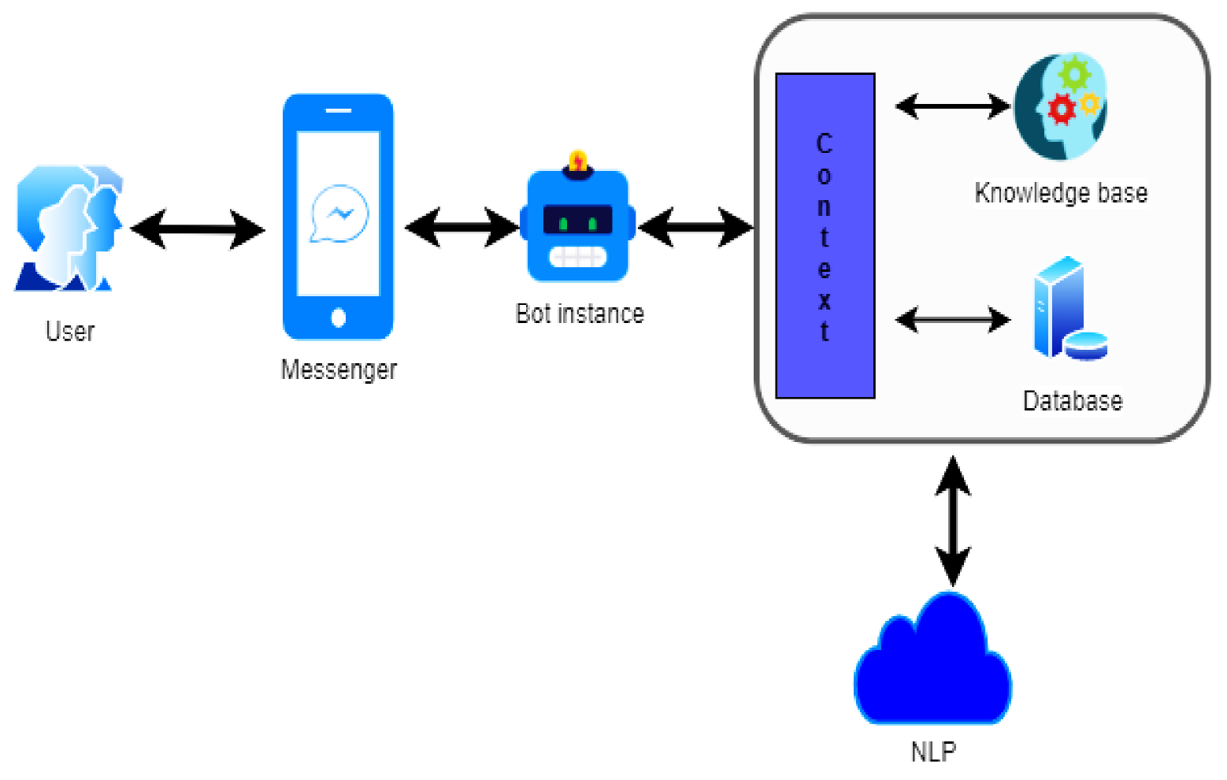

Fig No. 1:Block Diagram

**USE CASE DIAGRAM**

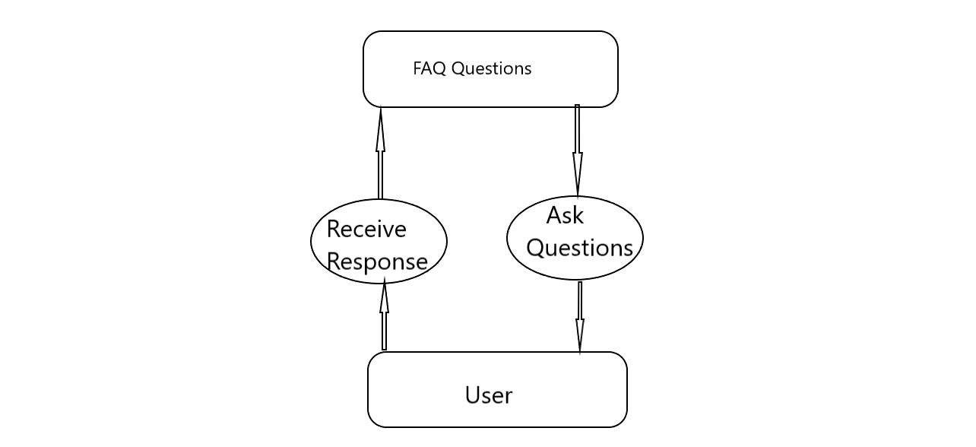

Fig No. 2: Use case diagram

**6. SYSTEM REQUIREMENT**

* **Software requirements:**
* Programming language:

Python has been selected as the primary programming language for the development of

the healthcare chatbot as it offers a wide range of libraries and frameworks suitable for

natural language processing, machine learning, and web development.

* Operating systems:

Any operating system including Windows, macOS, or Linux.

* Development environment:

Visual Studio Code.

* **Hardware Requirements:**
* Processor: Any modern processor that is capable of running the program.
* RAM: At least 8GB RAM.
* Storage: SSD, 256GB+.
* CPU: : Multicore(Minimum I3-10th generation)

# 7.IMPLEMENTATION

**How to implement the application?**

**Initial user input:**

**The process commences with a user interface prompting the individual to provide**

**personal information, including name and age.**

**Symptom submission:**

**User has to submit their symptom.**

**Symptom assessment:**

**A** series of targeted questions are presented to the user, aimed at eliciting further

details regarding their reported symptoms.

Diagnosis notification:

Users are promptly informed of the probable illness diagnosis based on the provided

information.

Precautionary measures:

Concluding the diagnostic process, a comprehensive list of precautionary measures

tailored to the identified illness is presented to the user for their reference.

# 8.RESULT

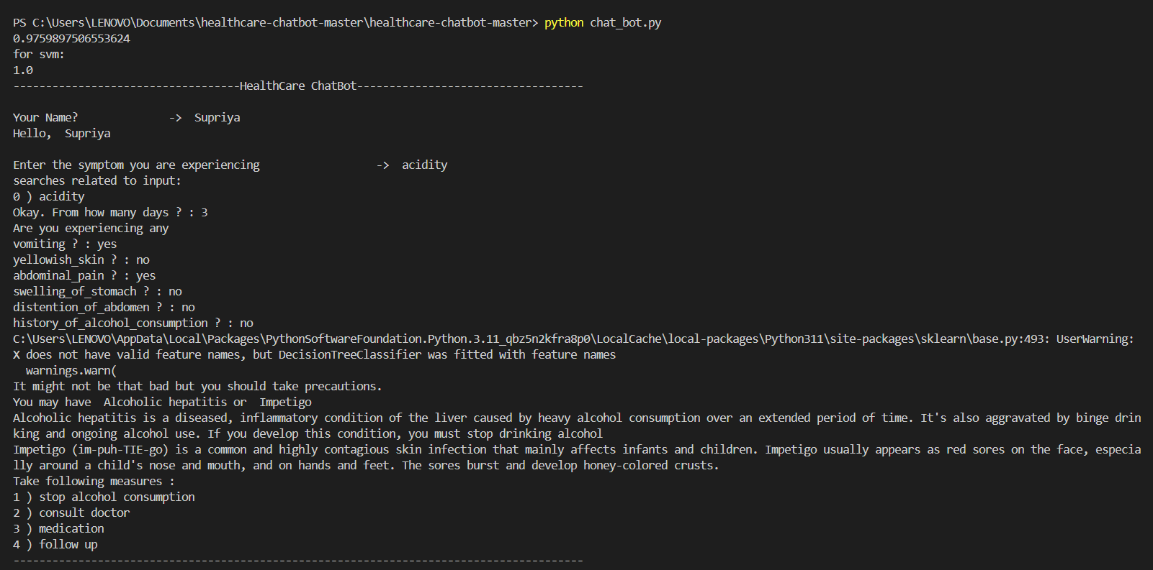

Fig: Terminal output

# 9.FUTURE SCOPE

* Personalized Assistance: They'll offer tailored recommendations based on individual health data.
* Integration with Wearables: Chatbots will sync with wearable devices for real-time health monitoring.
* Advanced NLP: They'll understand natural language better, enhancing user interactions.
* Virtual Health Assistants: Chatbot will autonomously manage medical tasks like consultations.
* Emotional Support: They'll provide empathetic responses and interventions for mental health.
* AR/VR Integration: Chatbots will utilize AR/VR for immersive medical education and consultations.
* Healthcare Education: They'll facilitate learning for medical professionals and patients through interactive experiences.
* Research Contribution: Chatbots will aid medical research by collecting and analyzing data from patient interactions.
* Global Accessibility: They'll improve healthcare access for underserved populations through remote services.
* Ethical Compliance: Developers will prioritize user privacy and regulatory compliance as chatbots become more prevalent in healthcare

# 

# 10.CONCLUSION

Ithas been a pleasure to collaborate on this project, and we trust that its outcomes will prove beneficial

To user in future.

The chatbot will ensure the security and integrity of data, minimizing the risk of loss or unauthorized

access.

The chatbot will expedite user assistance, facilitating prompt access to relevant information and services

The chatbot facilitates informed decision making and empowers individuals to take proactive step for

Managing their health and well-being.

1. Top of Form

# 11.REFERENCES

1. <https://medicalfuturist.com/top-10-health-chatbots/>
2. <https://www.leadsquared.com/industries/healthcare/healthcare-chatbot/>
3. <https://www.ibm.com/products/watsonx-assistant/healthcare>
4. <https://yellow.ai/blog/healthcare-chatbot/>
5. [https://www.irjet.net/archives/V9/i2/IRJET-V9I2193](https://www.irjet.net/archives/V9/i2/IRJET-V9I2193.pdf)